**Engineering Project Detailed Research Plan**

**Please complete the information/questions begun/seen below in red ink. Save this document to your computer, and add a printed hardcopy to your application.**

**Date:** 10/22/22

**Student Name:** Ananya Mehta

**Project Title:** An Automatic Enforcer For Special Traffic Zones

Parts of the generic engineering project are listed below with descriptions to the students in the boxes. Students may provide a detailed research plan by describing their specific project in response to each box below.

**Engineering Goal**: PROBLEM BEING ADDRESSED: All engineering projects solve a problem or fill a need. This goal should be a simple statement that describes the product being designed, the customer it is for and the problem or need it satisfies. Example” “The goal is to design a solar powered lawn mower for inexpensive automated lawn care for homeowners”

**My Project Goal i**s:

The design and construction of an automotive system that will automatically enforce special driving zone requirements like speed, noise, and light levels.

**Design Criteria:** Design criteria define the product’s required performance . Examples: “ It will have a minimum speed of 10 KPH”, The output will be within 15% of the mean of the experimental data”. “It must withstand 15 repetitions of a 10N impact” The International System of units (SI) required.

**My Project Design Criteria are the following:**

* Must be able to receive instructions in the given distance 90% of the time
* Must be able to use instructions to correctly disable feature(s) 90% of the time
* When the car is out of a special zone, the system must be able to correctly enable all previously disabled feature(s) 90% of the time

**Constraints:** Constraints are factors that limit the engineer’s flexibility such as size, cost, and time limitations. Examples: “It must fit in a box no larger than 10x20x50 cm” “The maximum cost is $50” “The software must run in real time on a Raspberry Pi”

**My Project Constraints are the following:**

* Automotive software must have APIs to control the car’s system
* Must be able to prototype in 8 weeks
* System will not be able to control anything that is not integrated into the car (such as music playing on a phone)

**Provide your chosen design.** For hardware, provide a sketch.For software, provide a flowchart. Indicate the components you will develop, and the libraries you are using.

**My Project Design is shown below: insert photos, diagrams, or illustrations below.**

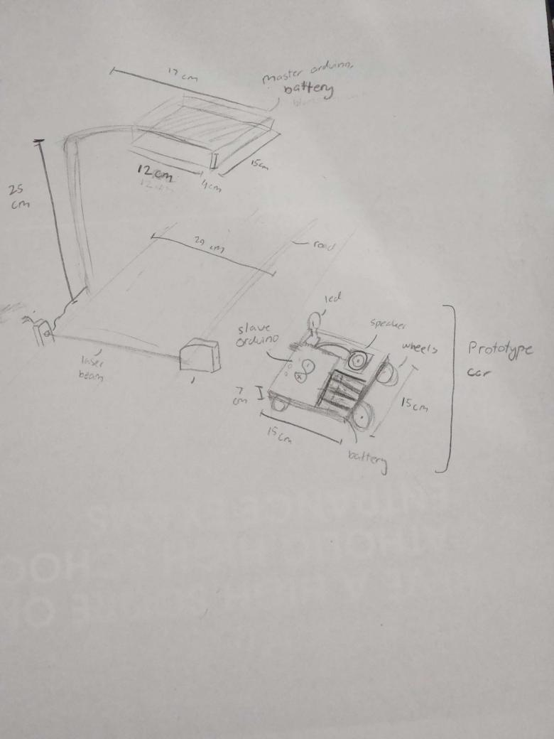

**Test and evaluate your prototypes against the design criteria listed above to show how well the product meets the need/goal.** Provide a test plan describing how you will test the design criteria and constraints you listed above., How will you analyze the data? If the product raequires human testing please fill out and append https://science-fair.org/wp/wp-content/uploads/2015/10/Research-Plan-Human-Participants.docx

**I test and analyze my prototypes using the following methods:**

Criteria #1 - Must be able to receive instructions in the given distance 90% of the time

1. Run program on master arduino. The program on master arduino will send out information.
2. Run program on slave arduino (on prototype car). The program on slave arduino will recieve information and display by turning on an LED.
3. Put slave arduino on a steady surface.
4. Put master arduino completely over the slave arduino, so that they are touching.
5. Slowly raise master arduino above the slave arduino, until the given distance (30 centimeters) is reached - measure with ruler
6. Record results - If LED is still on after the given distance (30 cm) is reached, trial is a success.
7. Stop program on master arduino and slave arduino
8. Repeat steps 1-6 ten times (10 trials)

Criteria #2 - Must be able to use instructions to correctly disable feature(s) 90% of the time

1. Put slave arduino on a steady surface, and put master arduino 25 cm directly above from the slave arduino
2. Run program on master arduino. The program on master arduino will send out information.
3. Run program on slave arduino (on prototype car). The program on slave arduino will recieve information and display by turning **off** a turned **on** LED.
4. If slave turns **off** the LED (on the prototype car) within 2 seconds, the trial is a success
5. Record results
6. Stop program on master arduino and slave arduino
7. Repeat steps 2-6 ten times (10 trials)
8. Put slave arduino on a steady surface, and put master arduino 25 cm directly above from the slave arduino
9. Run program on master arduino. The program on master arduino will send out information.
10. Run program on slave arduino (on prototype car). The program on slave arduino will recieve information and display by turning **off** a sound playing on a speaker (speaker is mounted on prototype car).
11. If slave turns off speaker **on** the prototype car within 2 seconds, the trial is a success
12. Record results
13. Stop program on master arduino and slave arduino
14. Repeat steps 8-12 ten times (10 trials)

Criteria #3 - When the car is out of a special zone, the system must be able to correctly enable all previously disabled features 90% of the time.

1. Put slave arduino on a steady surface, and put master arduino 25 cm directly above from the slave arduino
2. Run program on master arduino. The program on master arduino will send out information.
3. Run program on slave arduino (on prototype car). The program on slave arduino will recieve information and display by turning **on** a turned **off** LED.
4. If slave turns **on** the LED (on the prototype car) within 2 seconds, the trial is a success
5. Record results
6. Stop program on master arduino and slave arduino
7. Repeat steps 2-6 ten times (10 trials)
8. Put slave arduino on a steady surface, and put master arduino 25 cm directly above from the slave arduino
9. Run program on master arduino. The program on master arduino will send out information.
10. Run program on slave arduino (on prototype car). The program on slave arduino will recieve information and display by playing a sound **on** a previously turned off speaker (speaker is mounted on prototype car).
11. If slave turns **on** speaker on the prototype car within 2 seconds, the trial is a success
12. Record results
13. Stop program on master arduino and slave arduino
14. Repeat steps 8-12 ten times (10 trials)

**Bibliography:** List at least five (5) major references (e.g. science journal articles, books, internet sites & dates of review) from your literature review. If you plan to use vertebrate animals, one of these references must be an animal care reference.

1. [**https://www.circuitbasics.com/wireless-communication-between-two-arduinos/**](https://www.circuitbasics.com/wireless-communication-between-two-arduinos/)**, Date accessed: Oct 15, 2022**
2. [**https://www.bayareafastrak.org/en/support/fastrak-basics-faq2.shtml**](https://www.bayareafastrak.org/en/support/fastrak-basics-faq2.shtml)**, Date accessed: Oct 15, 2022**
3. [**https://garagedoorsca.com/garage-door-laser-photo-eye-important/**](https://garagedoorsca.com/garage-door-laser-photo-eye-important/)**, Date accessed: Oct 16, 2022**
4. [**https://littlebirdelectronics.com.au/guides/63/laser-sensor-for-arduino**](https://littlebirdelectronics.com.au/guides/63/laser-sensor-for-arduino)**, Date accessed: Oct 21, 2022**
5. [**https://create.arduino.cc/projecthub/Rad_Silviu/speaker-with-arduino-be454c**](https://create.arduino.cc/projecthub/Rad_Silviu/speaker-with-arduino-be454c)**, Date accessed: Oct 22, 2022**